**Compile all file one by one**

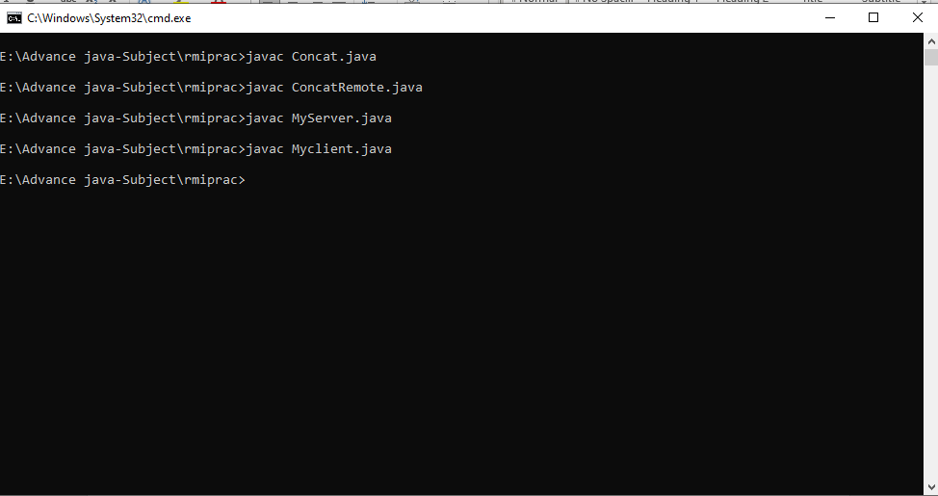

**create stub and skeleton object by rmic tool**

**start registry**

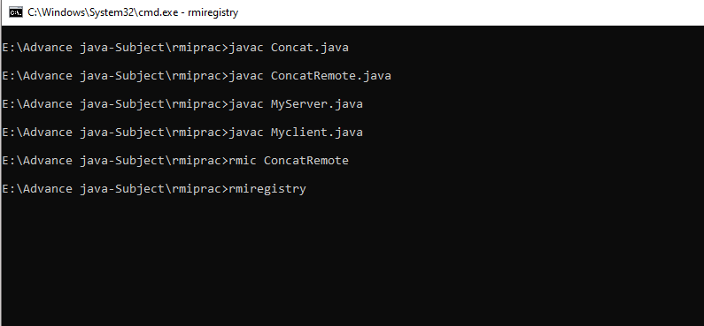

**Open Another New Terminal :** start the server in another command prompt  on same PC

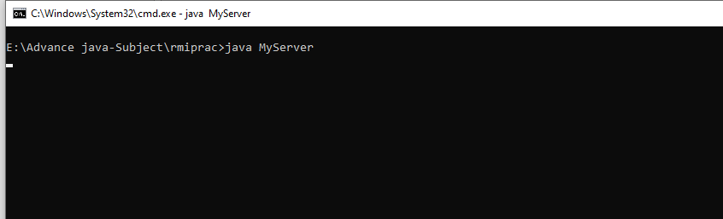

Open 3rd terminal start the client application in another command prompt

